**System Settings**

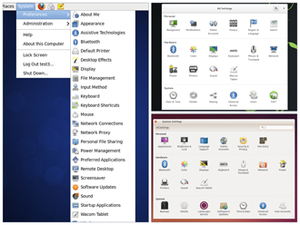

The **System Settings** panel allows you to control most of the basic configuration options and desktop settings such as specifying the screen resolution, managing network connections, or changing the date and time of the system.

As we mentioned in Chapter 4, we use the **GNOME Desktop Manager** for the visuals in this course as it is the default for **CentOS** and **Ubuntu** and readily available on **openSUSE** (for which the default is the **KDE Desktop Manager**).

The procedure to access **System Settings** varies according to distribution:

- **CentOS:** click System → Preferences.

- **openSUSE:** click **Activities**, type **Settings** in the **Search** box.

- **Ubuntu**:they are located in the panel on the left of the screen.

**Display Settings**

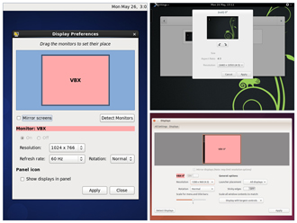

The **Displays** panel under **System Settings** (or **Display and Monitor** panel under **Configure Desktop**) contains the most common settings for changing the desktop appearance. These settings function independently of the specific display drivers you are running.

If your system uses a proprietary driver such as those from **nVidia** or **AMD**, you will probably have a configuration program for that driver that is not included in **System Settings**. This program may give more configuration options, but may also be more complicated, and might require sysadmin (root) access. If possible, you should configure the settings in the **Displays** panel rather than the proprietary configuration program.

The **X** server, which actually provides the GUI, uses the /etc/X11/xorg.conf file as its configuration file *if it exists*. In modern Linux distributions, this file is usually present only in unusual circumstances, such as when certain less common graphic drivers are in use. Changing this configuration file directly is usually for more advanced users.

**Setting Resolution and Configuring Multiple Screens**

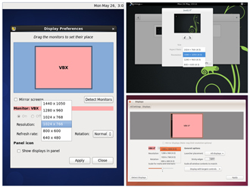

While your system will usually figure out the best resolution for your screen automatically, it may get this wrong in some cases, or you might want to change the resolution to meet your needs.

You can accomplish this using the **Displays** panel. The switch to the new resolution will be effective when you click **Apply**, and then confirm that the resolution is working. In case the selected resolution fails to work or you are just not happy with the appearance, the system will switch back to the original resolution after a short timeout.

In most cases the configuration for multiple displays is set up automatically as one big screen spanning all monitors, using a reasonable guess for screen layout. If the screen layout is not as desired, a check box can turn on mirrored mode, where the same display is seen on all monitors.

**Date and Time Settings**

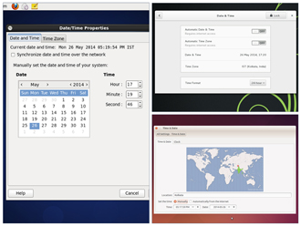

Linux always uses **Coordinated Universal Time (UTC)** for its own internal time-keeping. Displayed or stored time values rely on the system time zone setting to get the proper time. UTC is similar to, but more accurate than, Greenwich Mean Time (GMT).

The **Date** **and Time Settings** window can be accessed from the **System Settings** window. Alternatively, you can right-click **Date and Time** on the top panel to access the **Date and Time Settings** window.

**Network Time Protocol**



The **Network Time Protocol (NTP)** is the most popular and reliable protocol for setting the local time via Internet servers. Most Linux distributions include a working NTP setup which refers to specific time servers run by the distribution. This means that no setup, beyond "on or off", is required for network time synchronization. If desired, more detailed configuration is possible by editing the standard NTP configuration file (/etc/ntp.conf) for Linux NTP utilities.

**Network Configuration**

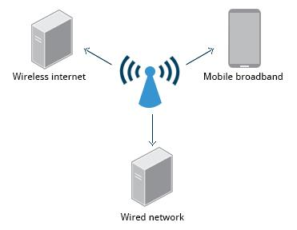

All Linux distributions have network configuration files, but file formats and locations can differ from one distribution to another. Hand editing of these files can handle quite complicated setups, but is not very dynamic or easy to learn and use. The **Network Manager** utility was developed to make things easier and more uniform across distributions. It can list all available networks (both wired and wireless), allow the choice of a wired, wireless or mobile broadband network, handle passwords, and set up **Virtual Private Networks (VPNs)**. Except for unusual situations, it’s generally best to let the **Network Manager** establish your connections and keep track of your settings.

In this section, you will learn how to manage network connections, including wired and wireless connections, and mobile broadband and VPN connections.

* [Previous](https://courses.edx.org/courses/LinuxFoundationX/LFS101x/2T2014/courseware/b2924cc4ea3644e1a56d04d2f4ee5cd7/79ee7c3dbca34501b028ab419e0734c3/1#)
* [Next](https://courses.edx.org/courses/LinuxFoundationX/LFS101x/2T2014/courseware/b2924cc4ea3644e1a56d04d2f4ee5cd7/79ee7c3dbca34501b028ab419e0734c3/1#)

**Wired and Wireless Connections**

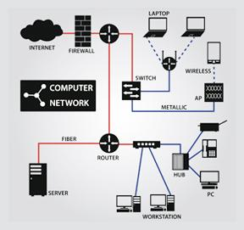

Wired connections usually do not require complicated or manual configuration. The hardware interface and signal presence are automatically detected, and then **Network Manager** sets the actual network settings via **DHCP** (Dynamic Host Control Protocol).

For **static** configurations that don't use **DHCP**, manual setup can also be done easily through **Network Manager**. You can also change the **Ethernet Media Access Control (MAC)** **address** if your hardware supports it. (The MAC address is a unique hexadecimal number of your network card.)

Wireless networks are not connected to the machine by default. You can view the list of available wireless networks and see which one you are connected to by using **Network Manager.** You can then add, edit, or remove known wireless networks, and also specify which ones you want connected by default when present.

* [Previous](https://courses.edx.org/courses/LinuxFoundationX/LFS101x/2T2014/courseware/b2924cc4ea3644e1a56d04d2f4ee5cd7/79ee7c3dbca34501b028ab419e0734c3/1#)
* [Next](https://courses.edx.org/courses/LinuxFoundationX/LFS101x/2T2014/courseware/b2924cc4ea3644e1a56d04d2f4ee5cd7/79ee7c3dbca34501b028ab419e0734c3/1#)

**Configuring Wireless Connections in CentOS**

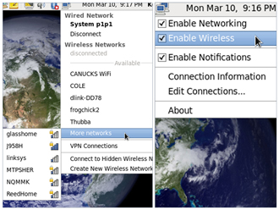

To configure a Wireless Network in **CentOS**:

1. Right-click the **Network Manager** icon.
2. Select the **Enable Wireless** check box.
3. Click the **Network Manager** icon.
4. Select the wireless network you wish to connect to or **More Networks** if the network you want is not in the first group shown.
5. Enter the password to access a secure wireless network the first time you connect to that network. The password will be saved for subsequent connections.
6. To view your current network interface connections and to disconnect if desired, click the **Network Manager** icon.

**Configuring Wireless Connections in Ubuntu**

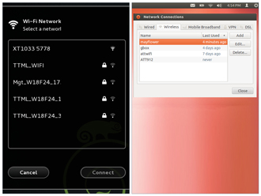

To configure **Wireless Network** in **Ubuntu**:

1. In top panel, click **Network Manager**.
2. Click **Enable Wi-Fi** - to display a list available **Wireless Networks**.
3. Click the desired **Wireless Network**.
4. For a secured network, enter the password.
5. To modify saved wireless network settings, click **Edit Connections**.

**Configuring Wireless Connections in openSUSE**

**openSUSE** looks different from **CentOS** or **Ubuntu**, but Wired, Wireless, Mobile Broadband, VPN, and DSL are all available from the **Network Connections** dialog box as you will see in the upcoming demonstration.

**The next few screens are demonstrations for the Linux distributions that we cover in this course. You can view a demonstration for the distribution family of your choice.**

**Mobile Broadband and VPN Connections**



You can set up a mobile broadband connection with **Network Manager**, which will launch a wizard to set up the connection details for each connection.

Once the configuration is done, the network is configured automatically each time the broadband network is attached.

**Network Manager** can also manage your VPN connections.

It supports many VPN technologies, such as native **IPSec**, **Cisco OpenConnect** (via either the Cisco client or a native open-source client), **Microsoft PPTP**, and **OpenVPN**.

You might get support for VPN as a separate package from your distributor. You need to install this package if your preferred VPN is not supported.

**Installing and Updating Software**



Each **package** in a Linux distribution provides one piece of the system, such as the Linux **kernel,** the **C** compiler, the shared software code for interacting with **USB** devices, or the **Firefox** web browser.

Packages often depend on each other; for example, because **Firefox** can communicate using SSL/TLS, it will depend on a package which provides the ability to encrypt and decrypt SSL and TLS communication, and will not install unless that package is also installed at the same time.

One utility handles the low-level details of unpacking a package and putting the pieces in the right places. Most of the time, you will be working with a higher-level utility which knows how to download packages from the Internet and can manage dependencies and groups for you.

In this section, you will learn how to install and update software in Linux using the **Debian** and **RPM** systems (which is used by both **Fedora** and **SUSE** family systems).

**Debian Family System**

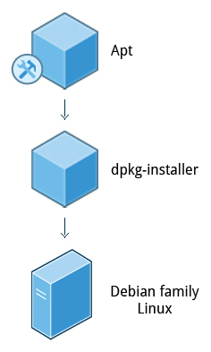

Let’s look at **Package Management** in the **Debian** Family System.

**dpkg** is the underlying package manager for these systems; it can install, remove, and build packages. Unlike higher-level package management systems, it does not automatically download and install packages and satisfy their dependencies.

For Debian-based systems, the higher-level package management system is the **apt** (**A**dvanced **P**ackage **T**ool) system of utilities. Generally, while each distribution within the **Debian** family uses **apt**,it creates its own user interface on top of it (for example, **apt-get**, **aptitude**, **synaptic**, **Ubuntu Software Center**, **Update Manager**, etc). Although **apt** repositories are generally compatible with each other, the software they contain generally isn’t. Therefore, most **apt** repositories target a particular distribution (like **Ubuntu**), and often software distributors ship with multiple repositories to support multiple distributions. The demonstration using the **Ubuntu Software Center** is shown later in this section.

* [Previous](https://courses.edx.org/courses/LinuxFoundationX/LFS101x/2T2014/courseware/b2924cc4ea3644e1a56d04d2f4ee5cd7/edfb50c8c27b4f049da791aeed0457e0/1#)
* [Next](https://courses.edx.org/courses/LinuxFoundationX/LFS101x/2T2014/courseware/b2924cc4ea3644e1a56d04d2f4ee5cd7/edfb50c8c27b4f049da791aeed0457e0/1#)

**Red Hat Packet Manager (RPM)**

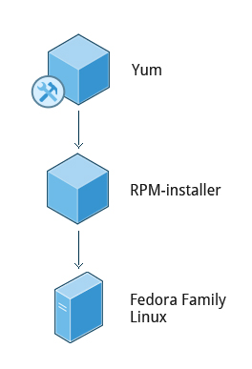

**Red Hat Package Manager (RPM)** is the other package management system popular on Linux distributions. It was developed by **Red Hat**, and adopted by a number of other distributions, including the **openSUSE**, **Mandriva**, **CentOS**, **Oracle Linux**, and others.

The high-level package manager differs between distributions; most use the basic repository format used in **yum** (Yellowdog Updater, Modified - the package manager used by **Fedora** and **Red Hat Enterprise Linux**), but with enhancements and changes to fit the features they support. Recently, the **GNOME** project has been developing **PackageKit** as a unified interface; this is now the default interface for **Fedora**.

**openSUSE’s YaST Software Management**

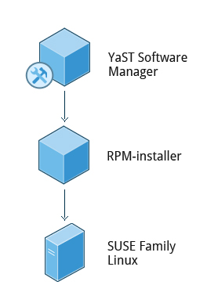

Before **openSUSE 13.1**, **Apper** was used for Software Management. Now it has been replaced by the **YaST** (**Y**et **a**nother **S**ystem **T**ool) **Software Manager**.

The **YaST Software Manager** is similar to other graphical package managers. It is an **RPM-**based application. You can add, remove, or update packages using this application very easily. To access the **YaST Software Manager**:

1. Click **Activities**
2. In the **Search** box type **YaST**
3. Click the **YaST** icon
4. Click **Software Management**

**openSUSE’s YaST Software Management** application is similar to the graphical package managers in other distributions. The demonstration of the **YaST Software Manager** is shown later in this section.

* [Previous](https://courses.edx.org/courses/LinuxFoundationX/LFS101x/2T2014/courseware/b2924cc4ea3644e1a56d04d2f4ee5cd7/edfb50c8c27b4f049da791aeed0457e0/1#)